**Wireframe Index para [desktop y celular](https://www.google.com/search?client=avast-a-1&sa=X&bih=721&biw=1152&hl=es-419&sxsrf=APwXEdfM-V43qE8522rvhqZB9JpYusD4sw:1682800761662&q=desktop+y+celular&tbm=isch&source=univ&fir=t4QW4IG7tXOUrM%252CWv4YU-hy2-hwNM%252C_%253Bkww-Jlze5EkUvM%252C4Pfp-HWv2GqlyM%252C_%253Bjtau-GmOJJ1sPM%252CLKgZasTcWAWoGM%252C_%253BG8GZQsIIqvfrfM%252CoMOhN7gYRyX_yM%252C_%253BFX84xc21_mIfbM%252CggK-gSHnz4zT6M%252C_%253BnYG0sHM__zOkPM%252CBUHl5WRc4gtn8M%252C_%253B5R2IvNOiBWi6aM%252C86q_kx1ap6H3wM%252C_%253BrrPzmd1ljdIMnM%252CWv4YU-hy2-hwNM%252C_%253BaeIBT6WO7eshyM%252Cknqf9Pjtk1NnMM%252C_%253BDZmxH5VMGQQxzM%252CRun9qQ16fO_L1M%252C_&usg=AI4_-kREx0-OHSdy87RWVsPysjs9LLyKtg&ved=2ahUKEwjAnoGt-c_-AhXvLbkGHfkuBs8QjJkEegQIVxAC)**

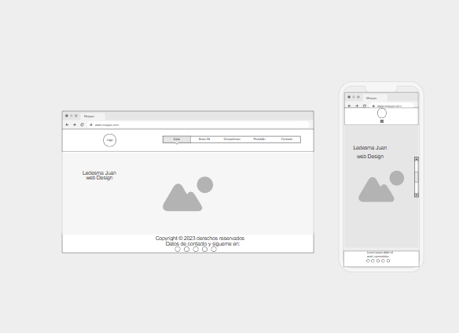

**Wireframe Sobre Mi para [desktop y celular](https://www.google.com/search?client=avast-a-1&sa=X&bih=721&biw=1152&hl=es-419&sxsrf=APwXEdfM-V43qE8522rvhqZB9JpYusD4sw:1682800761662&q=desktop+y+celular&tbm=isch&source=univ&fir=t4QW4IG7tXOUrM%252CWv4YU-hy2-hwNM%252C_%253Bkww-Jlze5EkUvM%252C4Pfp-HWv2GqlyM%252C_%253Bjtau-GmOJJ1sPM%252CLKgZasTcWAWoGM%252C_%253BG8GZQsIIqvfrfM%252CoMOhN7gYRyX_yM%252C_%253BFX84xc21_mIfbM%252CggK-gSHnz4zT6M%252C_%253BnYG0sHM__zOkPM%252CBUHl5WRc4gtn8M%252C_%253B5R2IvNOiBWi6aM%252C86q_kx1ap6H3wM%252C_%253BrrPzmd1ljdIMnM%252CWv4YU-hy2-hwNM%252C_%253BaeIBT6WO7eshyM%252Cknqf9Pjtk1NnMM%252C_%253BDZmxH5VMGQQxzM%252CRun9qQ16fO_L1M%252C_&usg=AI4_-kREx0-OHSdy87RWVsPysjs9LLyKtg&ved=2ahUKEwjAnoGt-c_-AhXvLbkGHfkuBs8QjJkEegQIVxAC)**

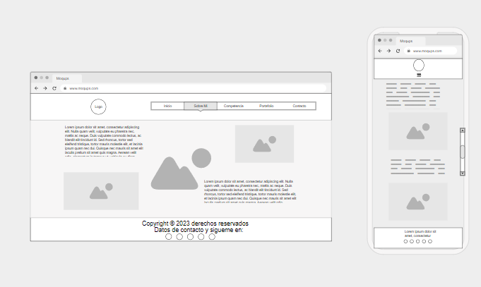

**Wireframe Skill para [desktop y celular](https://www.google.com/search?client=avast-a-1&sa=X&bih=721&biw=1152&hl=es-419&sxsrf=APwXEdfM-V43qE8522rvhqZB9JpYusD4sw:1682800761662&q=desktop+y+celular&tbm=isch&source=univ&fir=t4QW4IG7tXOUrM%252CWv4YU-hy2-hwNM%252C_%253Bkww-Jlze5EkUvM%252C4Pfp-HWv2GqlyM%252C_%253Bjtau-GmOJJ1sPM%252CLKgZasTcWAWoGM%252C_%253BG8GZQsIIqvfrfM%252CoMOhN7gYRyX_yM%252C_%253BFX84xc21_mIfbM%252CggK-gSHnz4zT6M%252C_%253BnYG0sHM__zOkPM%252CBUHl5WRc4gtn8M%252C_%253B5R2IvNOiBWi6aM%252C86q_kx1ap6H3wM%252C_%253BrrPzmd1ljdIMnM%252CWv4YU-hy2-hwNM%252C_%253BaeIBT6WO7eshyM%252Cknqf9Pjtk1NnMM%252C_%253BDZmxH5VMGQQxzM%252CRun9qQ16fO_L1M%252C_&usg=AI4_-kREx0-OHSdy87RWVsPysjs9LLyKtg&ved=2ahUKEwjAnoGt-c_-AhXvLbkGHfkuBs8QjJkEegQIVxAC)**

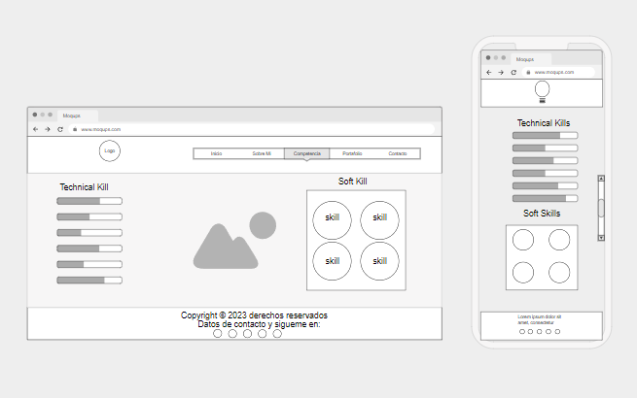

**Wireframe Portafolio para [desktop y celular](https://www.google.com/search?client=avast-a-1&sa=X&bih=721&biw=1152&hl=es-419&sxsrf=APwXEdfM-V43qE8522rvhqZB9JpYusD4sw:1682800761662&q=desktop+y+celular&tbm=isch&source=univ&fir=t4QW4IG7tXOUrM%252CWv4YU-hy2-hwNM%252C_%253Bkww-Jlze5EkUvM%252C4Pfp-HWv2GqlyM%252C_%253Bjtau-GmOJJ1sPM%252CLKgZasTcWAWoGM%252C_%253BG8GZQsIIqvfrfM%252CoMOhN7gYRyX_yM%252C_%253BFX84xc21_mIfbM%252CggK-gSHnz4zT6M%252C_%253BnYG0sHM__zOkPM%252CBUHl5WRc4gtn8M%252C_%253B5R2IvNOiBWi6aM%252C86q_kx1ap6H3wM%252C_%253BrrPzmd1ljdIMnM%252CWv4YU-hy2-hwNM%252C_%253BaeIBT6WO7eshyM%252Cknqf9Pjtk1NnMM%252C_%253BDZmxH5VMGQQxzM%252CRun9qQ16fO_L1M%252C_&usg=AI4_-kREx0-OHSdy87RWVsPysjs9LLyKtg&ved=2ahUKEwjAnoGt-c_-AhXvLbkGHfkuBs8QjJkEegQIVxAC)**

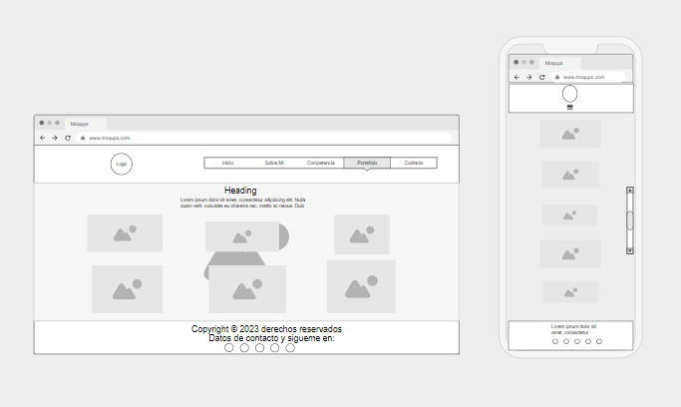

**Wireframe Contacto para [desktop y celular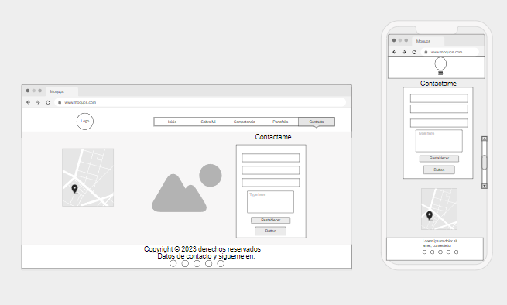](https://www.google.com/search?client=avast-a-1&sa=X&bih=721&biw=1152&hl=es-419&sxsrf=APwXEdfM-V43qE8522rvhqZB9JpYusD4sw:1682800761662&q=desktop+y+celular&tbm=isch&source=univ&fir=t4QW4IG7tXOUrM%252CWv4YU-hy2-hwNM%252C_%253Bkww-Jlze5EkUvM%252C4Pfp-HWv2GqlyM%252C_%253Bjtau-GmOJJ1sPM%252CLKgZasTcWAWoGM%252C_%253BG8GZQsIIqvfrfM%252CoMOhN7gYRyX_yM%252C_%253BFX84xc21_mIfbM%252CggK-gSHnz4zT6M%252C_%253BnYG0sHM__zOkPM%252CBUHl5WRc4gtn8M%252C_%253B5R2IvNOiBWi6aM%252C86q_kx1ap6H3wM%252C_%253BrrPzmd1ljdIMnM%252CWv4YU-hy2-hwNM%252C_%253BaeIBT6WO7eshyM%252Cknqf9Pjtk1NnMM%252C_%253BDZmxH5VMGQQxzM%252CRun9qQ16fO_L1M%252C_&usg=AI4_-kREx0-OHSdy87RWVsPysjs9LLyKtg&ved=2ahUKEwjAnoGt-c_-AhXvLbkGHfkuBs8QjJkEegQIVxAC)**

**Wireframe para celulares**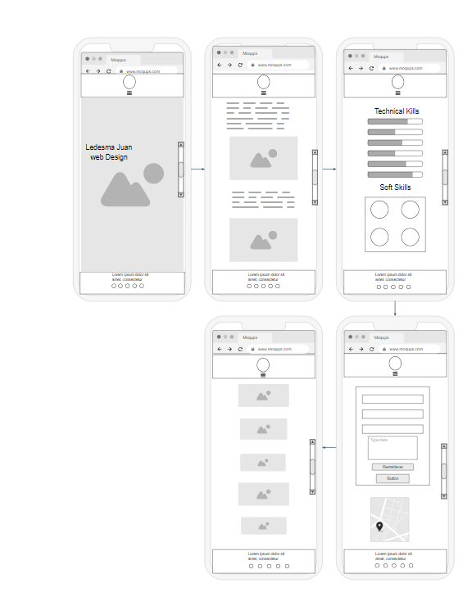

Desktop y celular